Copeland Showcases Groundbreaking Innovations at 2025 China Refrigeration Expo
Pioneering Sustainable Solutions to Drive Decarbonization and Energy Efficiency
SHANGHAI (April 28, 2025) – Copeland, a global leader in sustainable heating, cooling, cold chain, and industrial solutions, unveiled its latest cutting-edge innovations at the 2025 China Refrigeration Expo, held from April 27 to 29 in Shanghai, China. As a longstanding exhibitor and industry pioneer, Copeland designed a unique showcase featuring four themed areas – commercial, industrial, cold chain, and residential – each zone spotlighted advanced solutions engineered to maximize energy efficiency and minimize environmental impact.
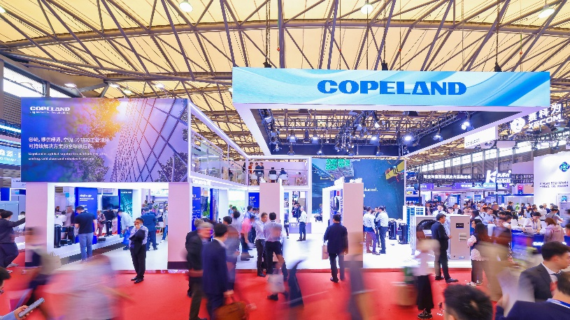
"Sustainability is a top global priority, and Copeland is well-equipped with robust technologies to help various end markets meet this challenge," said Michael Toh, president of Asia-Pacific for Copeland. "We are excited to leverage the China Refrigeration Expo to drive meaningful progress alongside our customers in China and across Asia."
China’s rapid urbanization and industrialization are driving demand for sustainable refrigeration and HVAC solutions as the country works toward its 2060 carbon neutrality goals. The HVAC market, projected to grow at a compound annual growth rate (CAGR) of over 6% through 2030 *, is being shaped by stricter energy efficiency standards. This demand is further amplified by rapidly growing end markets, such as China’s digital economy, which has nearly doubled since 2016*, and is expected to grow at 20% annually *.
Copeland is addressing these challenges by focusing on three key global priorities: advancing the energy transition, accelerating the adoption of climate-friendly low-GWP refrigerants, and safeguarding the world's most critical goods through a sustainable cold chain. The innovations presented at the exhibition align with these strategies, showcasing Copeland's dedication to supporting decarbonization goals in China and beyond.
Advancing the Energy Transition
Data Center solution: Addressing the growing demand for sustainable data center thermal management, Copeland unveiled its innovative oil-free centrifugal compressor featuring advanced Aero-Lift™ technology. This state-of-the-art compressor delivers outstanding high-lift capabilities and rapid startup, ensuring reliable and efficient performance under challenging operating conditions.

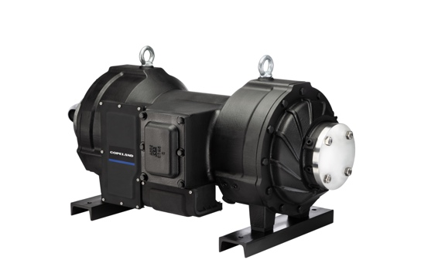
Copeland oil-free centrifugal compressor with Aero-Lift™ technology
- Energy Storage & Sustainable Transportation solution: Copeland launched advanced solutions for thermal management in the new energy sector, including the Copeland ZPVH068 compressor for e-buses and the ZEV/YEV Series compressors for energy stations. These innovations deliver exceptional e-bus passenger coach and battery thermal management using a single compressor with superior capacity ratio. Copeland reliability and safety is built in with eco-friendly refrigerants to ensure minimal environmental impact.

- District Heating Solution: To support energy efficiency standards in commercial HVAC applications, Copeland introduced the new R-32 LPI and FW range compressors. These products deliver a powerful 50HP single-unit capacity while offering exceptional performance in ultra-low ambient temperatures, with the minimum evaporation temperature extended to -40℃.
Accelerating Low-GWP Refrigerant Adoption
- Full range of low-GWP refrigerants application solutions: The transition to low-GWP refrigerants is central to sustainability, and Copeland is at the forefront of this shift. Copeland showcased its industry-leading portfolio of low-GWP solutions, covering R-454B, R-32, R-290, and CO2, which support customers in achieving regulatory compliance and sustainability objectives.
Supporting Sustainable Cold Chain
- Large Cold Storage Refrigeration Solution: To meet the growing demand for high-capacity refrigeration, Copeland launched the new 50HP ZFI180 low-temperature large commercial refrigeration scroll compressor, offering lower operation cost and advanced diagnostics and protection features delivering unmatched reliability to safeguard food and pharma along its journey.

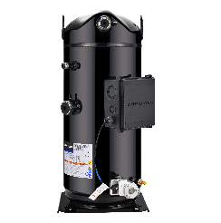
Copeland 50HP ZFI180 low temperature scroll compressor

To enable food retail chains to deliver operation cost reduction, Copeland expanded its Digital Condensing unit product line with ZXD100HE digital condensing unit. This versatile product line along with advanced monitoring solutions delivers superior efficiency with ease of maintenance to enable end-users meet their sustainability goals.
In recognition of its continuous innovation and exceptional product performance, Copeland received two China Refrigeration Expo Innovation Product Awards for its groundbreaking products. During the show, Copeland also hosted a series of technical seminars to engage with partners and customers, sharing insights on the latest trends.
"Our innovative solutions empower customers at every stage of their decarbonization journey, delivering efficiency, reliability, and sustainability," concluded Michael Toh. "Through relentless innovation, we are committed to advancing a greener, smarter, and low-carbon future for China and the world, protecting the planet and improving lives today and for generations to come."
Learn more about Copeland’s sustainable solutions at Copeland.com.

###

About Copeland
Copeland is a global leader in sustainable heating, cooling, cold chain and industrial solutions. We help commercial, industrial, refrigeration and residential customers reduce their carbon emissions and improve energy efficiency. We address issues like climate change, growing populations, electricity demands and complex global supply chains with innovations that advance the energy transition, accelerate the adoption of climate friendly low GWP (Global Warming Potential) and natural refrigerants, and safeguard the world's most critical goods through an efficient and sustainable cold chain. We have over 18,000 employees, with feet on the ground in more than 40 countries - a global presence that makes it possible to serve customers wherever they are in the world and meet challenges with scale and speed. Our industry-leading brands and diversified portfolio deliver innovation and technology proven in over 200 million installations worldwide. Together, we create sustainable solutions that improve lives and protect the planet today and for future generations. For more information, visit copeland.com.

Contact
Claire He
Claire.he@copeland.com

